Report

～ Analyzing The Presentation of American President ～

J5-180227 Rei Kinoshita

Introduction

In the global world, there are opportunities for us to have a presentation.

When we have the presentation, it is important to do a good presentation which makes strong impression on people. In this report, I`ll analyze the speech made by American present and compare them．Also, I`ll investigate what is important to have an excellent presentation by their techniques.

Theoretical Framework ＆　Literature Review

There are many books which write about the techniques of presentation.

Prof.Fujio also writes about them in the book “English Presentation Only Japanese Can Do”. There are listed many techniques.

In Analyze & Discussion session, I`ll mainly analyze the speech of Barack Obama and Donald Trump and pick up Hilary Clinton to compare with them. Indeed, I`ll find their commonly used and distinctive techniques which we should refer to and master as our own techniques.

Analyze & Discussion

1. Key Point of Obama`s Speech

・Repetition

・Pause

1. Repetitions

Fujio(2016) says that repeating the same phrase and being a simple structure are the most important points to make impressive presentation and Obama follows these key points in his presentation.

The typical example is 「Yes, we can」　This sentence has the simplest structure. But he uses more and more repetition.

　　Here are another examples I found in his script.

Ex1) if you feel **the same** energy **I do**, **the same** urgency **I do, the same** passion **I do, the same** hopefulness **I do** –

Ex2) It’s **the hope of** slaves sitting around a fire singing freedom songs; **the hope of** immigrants setting out for distant shores; **the hope of** a young naval lieutenant bravely patrolling the Mekong Delta; **the hope of** a millworker’s son who dares to defy the odds; **the hope of** a skinny kid with …

Ex3)**That's why** we do this. **That's what** politics can be. **That's why** elections matter. It's not small, it's big. It's important.

1. Pause

Fujio(2016) says pausing is used to emphasize important keywords and to attract the audience by making them want to know what he says next. Pausing is the most distinctive feature of his speech.

Table-1 shows that Obama uses much more pauses in 1 min than others.



1. Key Point of Trump`s Speech

・Rhythm

・Repetition

・Word selection

*Gestures

1. Rhythm

I found his talking is very rhythmical.

The representative example of his rhythmical phrase is

「Make America Great Again」

Rhythmical phrase are easily remembered and this phrase became a catchphrase of Trump`s speech in president election.

(2)Repetition

As I mentioned before, repetition makes strong impression on people and Trump also use this technique. But I found Trump uses few repetition than Obama. Here are examples.

Ex1) **No** dream **is too big, no** challenge **is too great**. Nothing we want for our

future is beyond our reach.

Ex2) **Make America** strong **again. Make America** wealthy **again.**

**Make** **America** prosper **again.** **Make America** proud **again.**

**Make America** safe **again. Make America** Great **again.**

(This repetition can be seen in the video which I pick up in Gesture section. If you see after reading Gesture section, this video will make awfully strong impression on you.)

(3)Words selection

It is often said that he uses violent words which are not appropriate for president. One of the reason of this may be his character. However, I found there is another reason. It is that his violent words plays a role in strengthening his radical policy. Violent words are used to show his stormy enthusiasm on his policy.

*Gestures

Gestures plays a very important role in his speech. Gesture-1

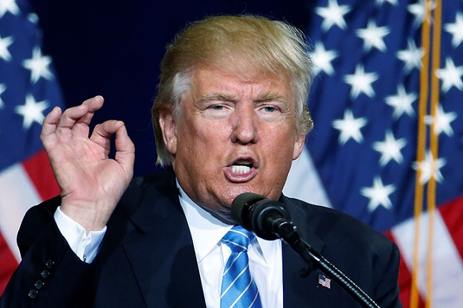 He uses many gestures, especially the gesture shown in

right picture(Gesture-1 , Robert Phillip says this gesture

shows that he is confident or he wants audience to listen to

what he says.)

When he says important phrase which must be emphasized,

(for example, rhythmical phrase, violent words and so on)

he uses gesture like Gesture-1 and largely waves his hand

up to down with every words. This action makes strong

impression on us because the rhythm of doing gestures matches with the rhythm

of saying words and it makes dual impression (visual and auditory impression). We receive his speech not only by ears but also by eyes and it makes us to easily remember what he says.

Indeed, I found Trump is better at using gesture than Obama.

As described above, Trump uses the gesture of waving his hand up to down.

He often raise his hand to the level of his head (Gesture-1) and lower it. This big and sharp movement makes a strong impression and emphasizes the phrases he said because our eyes react to the big movement.

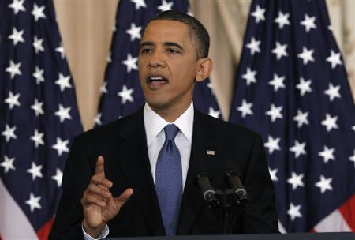But the gesture of Obama is small. Gesture-2

He waves his hand in front of his chest.(Gesture-2)

(But I think one of the reason is that he usually speaks

in tender accents and small gestures match with it.)

(About gestures Referenced video.

Donald　Trump

<https://www.youtube.com/watch?v=rgNw-O-2okk>

https://www.youtube.com/watch?v=a5wBY6D7V34Barack Obama

https://www.youtube.com/watch?v=udrKnXueTW0&t=302s <https://www.youtube.com/watch?v=nv9NwKAjmt0> )

Conclusion

Both Obama and Trump have a special techniques of speech.

Their style of speech is different, but both use repetition. To repeat something means to make audience remember it.

Other techniques are their distinctive features. Some of them, for example, pause and gesture is not difficult for us to practice. So I`ll make effort to acquire these techniques for my future.

Reference

Fujio, M [藤尾　美佐](2016)

Nihonnzinn dakarakoso dekiru Eigo purezennteisyonn. [日本人だからこそできる英語プレゼンテーション]. Kabusikigaisya DHC. [株式会社DHC]

Matt, J.(2017, July 25). What Donald Trump`s Gesture Really Mean. GQ

https://www.gq-magazine.co.uk/article/donald-trump-hand-gestures-politics